To: Agency Chief Fiscal Officers

From: OBM RACM General Ledger Team:
Randall Miller and Leondra Cummings
E-mail questions to OBM.Chartfield@obm.state.oh.us

Date: March 28, 2022

Re: FY 2023 Chartfield Values

The overall process for requesting Chartfield values is found in the FIN Process Manual ChartFields section of the OAKS FIN Process Manual under the ‘Chartfields/Steps for Chartfields’ section.

If your agency would like to establish new Chartfield values for the new fiscal year 2023, there are a couple of tips the GL team would like to pass on to help you determine proper Effective Dates (EFFDT) for your Chartfield values:

- Per the guidance found in the FIN Process Manual, All new Chartfield values must have an Active EFFDT of ’01-01-1901’ even if the value will not be used until a future date.

  - If your agency does not want the value to be available for coding immediately, please select the “Budgetary Only” option for the value on the Chartfield request form for the ’01-01-1901’ EFFDT request.

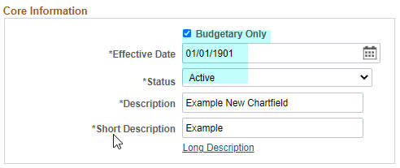

- For the DeptID and Program chartfields, please use the default Tree date that populates for the reporting tree.
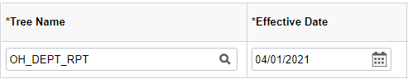
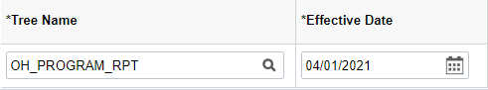

- You can add an additional row if you are also adding the value to a FIN Agency Budget translate tree (if applicable):

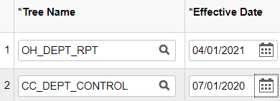

  - A second Chartfield request form should be submitted to update the Chartfield value with a new EFFDT row subsequent to the 01-01-1901 row with the ‘Budgetary Only” box unchecked. This will enable your agency to use the value for coding as of the EFFDT indicated. This EFFDT row can be in any date, whether past, present, or future, as long as it is after 01-01-1901.

  - If you submit a request and need to make a revision before it has been approved, please have the approver reject it back before you make changes to the Chartfield request form.

  - When choosing a future EFFDT that will make the Chartfield value available for coding, keep these dates in mind:
    - 06-19-2021 is the first day of the 07-02-2022 PPE (paycheck date 07-15-2022), which is the first pay period of FY 2023. To be able to use the Chartfield values in HCM Combo Codes for this pay period, please use an EFFDT to uncheck ‘Budgetary Only” on or prior to 06-19-2022.
    - Any Chartfield values needed for posting an Agency Budget for FY2023 can be “Budgetary Only” until 07-01-2022(unless needed for the 07-02-2022 PPE pay period, then the date must be 06-19-2022). The value must have an Active EFFDT ’01-01-1901’ row prior to posting the budget journal.

- Users with the Chartfield Requestor (OH_GL_AGY_COA_REQUESTOR) or Chartfield Approver (OH_GL_AGY_COA_APPROVER) roles will have the ability to make Chartfield requests until June 24, 2022. These COA security roles will be turned off from 06/25/22 through 6/30/2022 for the Year End Close processing so please plan accordingly.

If you have any questions, email: OBM.Chartfield@obm.state.oh.us.

